## Objective

* Display current date and time as obtained by the Hong Kong Observatory, in the appropriate format.
* Display the last synchronized date. In the case of an error, display the corresponding error message.

## Date Time Format

The current specified format for the date is

**YYYY/MM/DD**

* **YYYY** is the current year, with exactly 4 digits.
  + 2021
* **MM** is the current month of the year with exactly 2 digits.
  + February -> 02
  + December -> 12
* **DD** is the current day of the month with exactly 2 digits.
  + 5th -> 05
  + 28th -> 28

The current specified format for the time is

**HH:mm:ss**

* **HH** is the current hour of the day, in 24-hour format; from 0 to 23. With exactly 2 digits.
  + 5 p.m. -> 17
  + 1 a.m. -> 01
* **MM** is the current minute of the hour; from 0 to 59. With exactly 2 digits.
* **SS** is the current second of the minute; from 0 to 59. With exactly 2 digits.

## Workflow

1. Application startup
2. The application creates an HTTPS GET request to HKO servers, prompting for their current date time.
   1. **If the request succeeds**, the date is displayed on the top of the screen, and the time is displayed on the center of the screen
   2. **If the request fails**, the application creates a best estimate of current HKO time, and displays an error message on the screen
   3. A last synchronized date message is displayed on the bottom left corner of the screen
3. The request at (2) is performed at an interval of **5** seconds.

The last synchronized date message has the following formats:

When connection succeeds:

Last Synchronized: HH:mm:ss, YYYY/MM/DD

When connection fails (in red):

Connection Error, last synchronized: [ the last sync date in the same format ]

In regular operation, the application will prompt the HKO servers for their current time at a regular interval. At the moment that the application connects with the HKO servers, a last synchronized message is displayed.

In the case when the application failed to receive a response from the HKO servers, the application will display the connection error message as described above, and internally, estimate the current HKO time:

HKO Time T ≅ current machine time + 300 ms

## Sample

When connection succeeds:

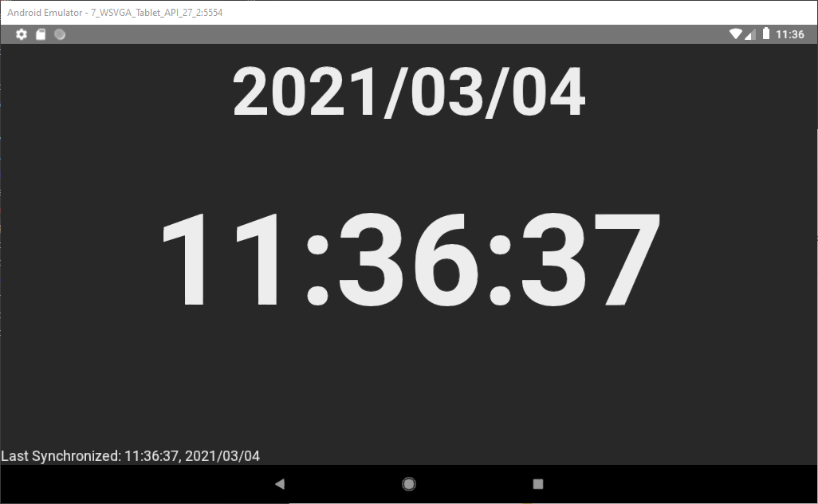

When connection fails:  
